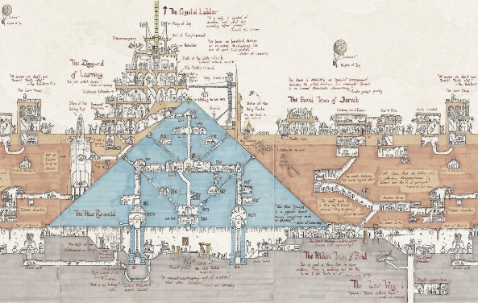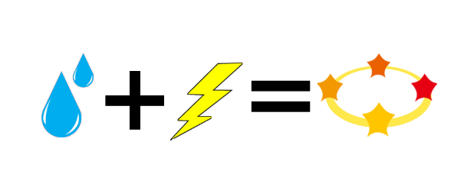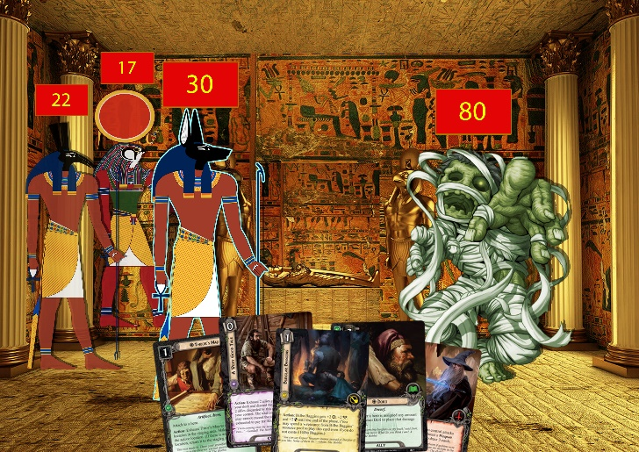

ASCENT

**Ascent** is a deckbuilding rogue-like game in which you play as a divine group of Egyptian creatures trying to ascend to Godhood. There are two main game modes, Ascent and Create a religion, which are different but influence each other’s gameplay.

**Combo system**: Combo status effects together to create a new one.

**Explore the Pyramids to Ascend:** The player needs to explore and discover the secretes the pyramids hide to gain the power need to reach Godhood.

**Three character turn-based combat**: The player controls three different entities each with its specific set of cards and abilities.